

YENEPOYA INSTITUTE OF ARTS, SCIENCE, COMMERCE AND MANAGEMENT
A CONSTITUENT UNIT OF YENEPOYA (DEEMED TO BE UNIVERSITY)
BALMATTA, MANGALORE

INTERNSHIP REPORT ON
DATA ANALYTICS
AUSTRIX TECHNOLOGIES LLC

SUBMITTED BY
SHIVAKANTH V
III BCA
( DATA SCIENCE AND BIG DATA ANALYTICS )
23BCDSBA78

UNDER THE GUIDANCE OF
MS. BHOOMIKA SUVARNA
LECTURER
DEPARTMENT OF COMPUTER SCIENCE

IN PARTIAL FULLFILLMENT OF THE REQUIREMENT
FOR THE AWARD OF THE DEGREE OF

BACHELOR OF COMPUTER APPLICATIONS
( DATA SCIENCE AND BIG DATA ANALYTICS )
MAY -2026

INTERNSHIP REPORT
ON
DATA ANALYTICS

Internship organization


Austrix Technologies LLC
Middle East | Africa | India
Web: www.auStrix.com, Email: mailus@auStrix.com

Under the guidance of
Ms. Bhoomika Suvarna
Lecturer,
Department of Computer Science
Submitted by
Shivakanth V
23BCDSBA78

BACHELOR OF COMPUTER APPLICATIONS

(Data Science and Big Data Analytics)

YENEPOYA INSTITUTE OF ARTS, SCIENCE, COMMERCE & MANAGEMENT
(A constituent unit of Yenepoya Deemed to be University)
Deralakatte, Mangaluru – 575018, Karnataka, India

CERTIFICATE

This is to certify that the project work entitled “Data Science and Big Data Analytics” has been successfully carried out at “Austrix Technologies LLC” by Shivakanth V (Reg. No. 23BCDSBA78), student of 3rd Year BCA (Data Science and Big Data Analytics) under the supervision and guidance of Ms. Bhoomika Suvarna, Lecturer, Department of Computer Science, Yenepoya Institute of Arts, Science, Commerce and Management. This dissertation is submitted in partial fulfilment for the award of degree in Bachelor of Computer Applications by Yenepoya (Deemed to be university) during academic year 2025-26.

Internal Guide: Ms. Bhoomika Suvarna Chairperson

Internal Examiner External Examiner

PRINCIPAL
Dr. Jeevan Raj
The Yenepoya Institute of Arts,
Science, Commerce and Management
(Deemed To be university)

Submitted for the viva-voice Place: Mangalore

Examination held on: Date:

DECLARATION

I, Shivakanth V a student of BCA (Data Science and Big Data Analytics) at Yenepoya Institute of Arts, Science, Commerce, and Management, Balmatta, Mangalore, affiliated with Yenepoya (Deemed to be University), hereby declare that this internship report titled IMDB Top 1000 Movies Exploratory Data Analysis is a genuine and original record of the work undertaken by me as part of my academic curriculum.
This report documents the knowledge, skills, and practical experience acquired during my internship at Austrix Technologies LLC. It includes methodologies, analytical processes, and investigative approaches aligned with recognized industry standards in digital forensics, incident response, and cybersecurity investigations.
I extend my sincere gratitude to Ms. Ayshath Lubna, Internship Program Head, for her valuable guidance, mentorship, and support throughout the internship period. I also express my appreciation to Austrix Technologies LLC for providing an enriching environment and exposure to real-world cybersecurity operations.
Furthermore, I acknowledge the support and encouragement received from my institutional guide, Ms. Bhoomika Suvarna, and the faculty of Yenepoya Institute of Arts, Science, Commerce, and Management. Their insights and assistance have been instrumental in successfully completing this internship.

Intern Signature:  Name: Shivakanth V  Date:  Internship Supervisor Signature:  Name: Ms. Ayshath Lubna  Designation: Internship Program Head  Organization:Austrix Technologies LLC  Date: | Institution Guide Signature:  Name: Ms. Bhoomika Suvarna  Institute: Yenepoya Institute of Arts, Science, Commerce, and Management  Date:  Head of the Department (HOD) Signature:  Name: Dr. Rathnakar Shetty P  Head of Department of Computer Science Institute: Yenepoya Institute of Arts, Science, Commerce, and Management  Date:

ACKNOWLEDGEMENT

I sincerely express my gratitude to Yenepoya Institute of Arts, Science, Commerce, and Management, affiliated with Yenepoya (Deemed to be University), Mangalore, for providing me with the opportunity to undertake this internship as part of my academic curriculum.
I extend my heartfelt thanks to Dr. Jeevan Raj, Principal, for his continuous support and guidance in facilitating this learning opportunity. I also express my sincere appreciation to Dr. Rathnakara Shetty P, Head of Department of Computer Science, for his encouragement and academic support throughout my internship journey.
I am deeply grateful to Ms. Ayshath Lubna for her visionary leadership and for fostering a dynamic learning environment in Austrix Technologies LLC. A special note of appreciation goes to Ms. Ayshath Lubna for her invaluable mentorship, expert guidance, and for sharing her vast experience in the field.
I also extend my sincere gratitude to Ms. Ayshath Lubna for her technical insights, hands-on training, and unwavering support during my internship. Their guidance has been instrumental in enhancing my practical understanding of cyber forensics and incident response methodologies.
I am also thankful to my internal guide, Ms. Bhoomika Suvarna, for her academic mentorship and for providing valuable insights that helped bridge the gap between theoretical learning and practical application.
Lastly, I am grateful to my faculty mentors, family, and peers for their encouragement and motivation throughout this journey.

Name: Shivakanth V
Reg NO: 23BCDSBA78
Date:

INTERNSHIP OFFER LETTER

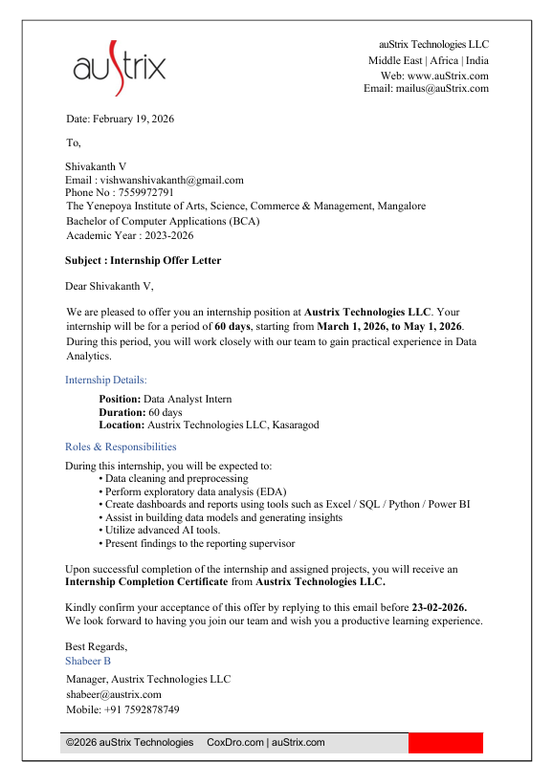

INTERNSHIP COMPLETION CERTIFICATE



COMPANY PROFILE: [Austrix Technologies]

Website:www.austrix.com Founded: 1999
Headquarters: Canada
Support Centers: USA, UAE, India, Qatar
Overview:
Austrix Technologies is a global provider of enterprise-grade web hosting and IT infrastructure solutions. With over two decades of experience, the company delivers scalable, secure, and high- performance hosting environments tailored for businesses of all sizes.
Core Services:
- Web & Email Hosting – High-speed, secure hosting with spam protection, DKIM support, and mailbox migration tools.
- Domain Registration – Global domain registration with DNS management.
- Cloud Solutions & Dedicated Servers – Reliable, scalable hosting infrastructure with 99.9% uptime.
- Custom Solutions – Digital signage, enterprise mail services, and application hosting customized for business needs.
Key Features:
- 24/7 Global Support
- Data Redundancy & Daily Backups
- Real-time Monitoring & Performance Dashboards
- Multi-layer Security (network, host, application)
- Disaster Recovery & RAID Technology

Why Austrix:
- Proven track record of reliable service delivery
- Infrastructure spread across continents

- Strong emphasis on data protection and uptime
Contact: Visit: www.austrix.com/contact-us.aspx

ROLES AND RESPONSIBILITIES
During the project, I was actively involved in performing end-to-end data analysis on the IMDB Top 1000 Movies dataset using Python and Microsoft Power BI. My responsibilities included data collection, pre-processing, exploratory analysis, visualization, dashboard development, and insight generation.

Data Collection and Understanding
I imported and worked with the IMDB Top 1000 Movies dataset using the Pandas library in Python. The dataset structure was explored using functions such as .info(), .head(), and .describe() to understand the nature of the data and identify important columns. I analysed key features including IMDB Rating, Number of Votes, Gross Earnings, Genre, Director, Actors, Runtime, and Released Year. Understanding the significance of these variables helped guide the analysis process and identify meaningful relationships within the dataset.

Data Cleaning and Preprocessing
I performed data cleaning and pre-processing to ensure the dataset was accurate, consistent, and suitable for analysis. Missing values were identified using .isnull().sum() and handled appropriately. The Gross column was cleaned and converted into numeric format, while the Runtime column was converted from text format into integer values. I verified and corrected data types to ensure accurate computations and analysis. Missing values in the Gross and Meta score columns were handled using mean imputation techniques. Additional data transformations were performed to improve analysis and visualization, including extracting and organizing genre information for genre-wise analysis.

Exploratory Data Analysis (EDA)
I conducted Exploratory Data Analysis (EDA) to identify trends, patterns, and relationships within the dataset. This included analyzing rating distributions among top movies, identifying top-rated and most popular movies based on audience votes, and examining the highest grossing and longest movies. I also studied genre distribution and average ratings across genres, identified top actors and directors based on frequency and performance, and examined movie release trends across different years.

Data Visualization
I created various visualizations using Matplotlib and Seaborn to represent analytical insights clearly and effectively. These visualizations included bar charts for top-rated movies, actors, and directors; horizontal bar charts for most popular movies; pie charts for gross revenue distribution; line plots for release year trends; scatter plots for analyzing relationships between votes and ratings; and heatmaps for correlation analysis. These visualizations simplified interpretation of complex movie data and improved presentation quality.

Power BI Dashboard Development
I designed and developed an interactive one-page dashboard using Microsoft Power BI for movie analysis and reporting. The dashboard included KPI cards displaying Total Movies, Average Rating, Total Votes, Total Gross Revenue, and Average Runtime. Interactive visualizations were created for top-rated movies analysis, most popular movies analysis, genre distribution, director and actor performance, gross revenue analysis, release year trends, and correlation analysis.

Filters and slicers were added for Genre, Release Year, and Certificate to improve user interaction and allow dynamic exploration of the data. I also applied dashboard formatting, themes, and layout customization to improve readability, usability, and visual appeal.

Trend and Relationship Analysis
I analysed trends in movie releases across different years and studied genre-wise patterns and rating behaviour. The relationship between audience popularity (votes) and gross earnings was examined to understand how popularity influences commercial success. Correlation analysis was performed among variables such as ratings, votes, gross revenue, and meta scores. These analyses helped identify important factors influencing movie success and audience engagement.

Insight Generation and Reporting
I generated meaningful insights from the analysis and prepared structured reports for presentation. Important findings such as the dominance of the Drama genre, top-performing actors and directors, and the influence of audience popularity on revenue generation were identified and interpreted. I explained trends related to genres, release years, and movie success patterns in a clear and understandable manner.

Finally, I presented the findings using both Python-based visualizations and Microsoft Power BI dashboards to improve understanding and communicate insights effectively.

LEARNING OUTCOMES

This project provided a valuable opportunity to apply theoretical knowledge of data analytics to a real-world movie dataset. Working on the IMDB Top 1000 Movies analysis helped me understand how raw data can be transformed into meaningful insights about movie ratings, popularity, revenue, genres, and factors influencing success.

Throughout this project, I gained both technical and analytical skills, along with a deeper understanding of how data-driven insights can support informed decision-making. I also gained practical exposure to dashboard development using Microsoft Power BI for interactive data visualization and reporting.

1. Understanding the Importance of Data Cleaning and Preparation
One of the most important lessons I learned during this project was the significance of data cleaning and preprocessing. Although the dataset was structured, it still required careful handling to ensure accuracy and reliability in analysis.

For example, the Gross column contained commas and needed to be converted into numeric format. Similarly, the Runtime column had to be cleaned and converted into integer values for proper analysis. Missing values in Gross and Meta_score were handled using mean imputation, and all data types were verified and corrected before analysis.

This experience taught me that data preprocessing is a critical stage in any analytics project because inaccurate or inconsistent data can lead to misleading analytical results.

2. Developing Strong Exploratory Data Analysis (EDA) Skills
This project helped me develop a strong foundation in Exploratory Data Analysis (EDA), which is essential for identifying trends, patterns, and relationships within datasets.

During the analysis, I explored:
- Ratings distribution across movies
- Top-rated and most popular movies based on votes
- Genre distribution and release year trends
- Performance of actors and directors
- Comparison of gross earnings among movies

Through this process, I discovered that audience popularity strongly influences movie success and that certain genres, actors, and directors dominate the dataset. EDA improved my ability to explore datasets effectively, ask relevant analytical questions, and extract meaningful insights.

3. Data Visualization and Interpretation
Another important learning outcome was representing data visually using Matplotlib and Seaborn.

I created various visualizations such as:
- Bar charts for top movies, actors, and directors
- Line charts for release year trends
- Pie charts for gross revenue distribution
- Scatter plots to study the relationship between votes and ratings
- Heatmaps to analyse correlations among variables

These visualizations made it easier to interpret complex data and communicate findings clearly. I learned that effective visualization plays a major role in storytelling with data, especially while presenting insights to technical and non-technical audiences.

4. Power BI Dashboard Development
One of the major skills I developed during this project was creating an interactive dashboard using Microsoft Power BI.

During dashboard development, I learned how to:
- Design a one-page movie analytics dashboard
- Create KPI cards for ratings, votes, runtime, and gross revenue
- Build interactive charts and visualizations
- Add filters and slicers for genre, release year, and certificate
- Organize dashboard layouts for better readability and user interaction

The dashboard transformed complex movie data into an interactive and visually appealing reporting system. This experience enhanced my understanding of business intelligence tools and dashboard-based reporting techniques.

5. Understanding Relationships Between Variables
One of the most valuable insights gained from this project was understanding the relationships between different variables.

Through analysis and correlation studies, I observed:
- A strong positive relationship between Number of Votes and Gross Earnings
- A moderate relationship between Ratings and Votes
- Popular movies generally generate higher revenue

I also analyzed release year trends and genre-wise rating patterns. This helped me understand how different factors interact and influence overall movie performance and audience engagement.

6. Analytical Thinking and Insight Generation
This project significantly improved my analytical thinking and problem-solving abilities.

- Instead of only creating graphs, I learned how to:
- Interpret results logically
- Connect findings to real-world industry scenarios
- Explain reasons behind trends and patterns

For example:

- High votes often indicate strong audience engagement, which can lead to higher earnings
- Drama dominates in quantity, while Western has higher average ratings, showing quality versus quantity
- Frequent appearances of certain actors and directors highlight their influence on successful films

This experience strengthened my ability to convert raw data into meaningful and actionable insights.

7. Communication and Presentation Skills
An important part of this project was presenting findings in a clear and structured manner.

I learned how to:
- Organize reports logically
- Write conclusions in a simple and understandable way
- Present technical insights clearly
- Explain analytical results during presentations and viva sessions
- Present insights effectively using Power BI dashboards and visual reports

This improved my confidence in communicating analytical findings effectively to different audiences.

Overall Learning Experience
Overall, this project enhanced my technical knowledge, analytical thinking, visualization skills, and reporting abilities. It provided practical exposure to real-world data analysis using Python and Power BI, and strengthened my confidence in handling data-driven projects and presenting meaningful insights effectively.

CERTIFICATIONS & OTHER ACTIVITIES

During the Data Analytics project, I successfully completed a structured and practical analysis workflow that provided hands-on experience in data preprocessing, exploratory data analysis, visualization, and dashboard development. The project followed a step-by-step analytical approach using Python libraries and Microsoft Power BI, enabling me to work with a real-world movie dataset and derive meaningful insights.

In the initial phase, I worked with the IMDB Top 1000 Movies dataset using Python and Pandas. I explored the dataset structure using functions such as .head(), .info(), and .describe() to understand the data and identify important fields like IMDB Rating, Number of Votes, Gross Earnings, Genre, Runtime, Directors, Actors, and Release Year.

During the data preprocessing stage, I performed data cleaning and transformation to ensure accuracy and consistency. The Gross column was cleaned and converted into numeric format, while the Runtime column was transformed into integer values for analysis. Missing values in Gross and Meta_score were handled using mean imputation, and all data types were verified and corrected for accurate computations and visualization.

In the exploratory data analysis (EDA) phase, I analyzed movie ratings, popularity, genres, actors, directors, runtime, release trends, and box office performance. I identified top-rated movies, most popular movies based on votes, highest grossing films, and longest movies in the dataset. I also performed genre-wise and director-wise analysis to understand patterns influencing movie success.

Further, I created visualizations using Matplotlib and Seaborn, including:
- Bar charts for top-rated movies, actors, and directors
- Horizontal bar charts for most popular movies
- Pie charts for gross revenue distribution
- Line charts for release year trends
- Scatter plots for votes vs ratings analysis
- Heatmaps for correlation analysis

These visualizations helped in understanding relationships among variables and communicating insights effectively.

As part of the project, I also developed an interactive dashboard using Microsoft Power BI. The dashboard included KPI cards, genre analysis, top movie analysis, actor and director performance, gross revenue insights, and trend visualizations. Interactive slicers and filters were added to improve user interaction and dashboard usability.

Through this project, I identified important insights such as:
- The strong relationship between audience votes and gross earnings
- The dominance of Drama genre in the dataset
- The influence of actors and directors on movie success
- Trends in movie releases across years
- The role of audience popularity in commercial success

This project helped me apply practical data analytics concepts to a real-world dataset and transform raw movie data into meaningful insights and interactive reports.

Overall, the project strengthened my skills in data analysis, visualization, dashboard creation, problem-solving, and insight generation. It also improved my confidence in working with real-world datasets and presenting analytical findings in a structured and professional manner.

ABSTRACT

In today’s data-driven world, analyzing movie and audience data plays an important role in understanding trends, popularity, and the factors influencing success in the entertainment industry. This project focuses on performing an in-depth analysis of the IMDB Top 1000 Movies dataset to understand patterns related to movie ratings, audience engagement, genres, revenue, directors, actors, and overall movie performance.

The dataset used in this project contains information such as IMDB ratings, number of votes, gross earnings, genres, directors, actors, runtime, certificates, and release years. Using Python and data analysis libraries such as Pandas, NumPy, Matplotlib, and Seaborn, the dataset was cleaned, processed, and analyzed to extract meaningful insights. Different analytical techniques including data preprocessing, grouping, aggregation, trend analysis, correlation analysis, and visualization were applied to identify patterns and relationships within the dataset.

The project also involved the development of an interactive dashboard using Microsoft Power BI to present insights visually and improve interpretability. The dashboard included KPI cards, genre analysis, top-rated movies, actor and director analysis, revenue analysis, and trend visualizations with interactive filters and slicers.

The analysis revealed several important insights. Drama emerged as the most dominant genre in the dataset, while movies such as The Shawshank Redemption, The Godfather, and The Dark Knight stood out as highly rated and popular films. The study also highlighted the strong influence of actors and directors on movie success, along with increasing representation of highly rated movies in recent years.

One of the most significant findings from the analysis was the strong positive relationship between audience votes and gross earnings, indicating that audience popularity plays a major role in commercial success. The project also showed how factors such as genre, release year, runtime, and audience engagement contribute to overall movie performance.

Overall, this project demonstrates how data analytics and visualization techniques can effectively transform raw movie data into meaningful insights. The findings help in understanding audience behavior, movie success factors, and entertainment industry trends, while also showcasing how data-driven approaches can support informed analysis and decision-making.

Table of context

Sl.no | Topic | Page No
1. | CHAPTER 1 : INTRODUCTION | 1-3
1.1 | Background | 1
1.2 | Objectives | 1
1.3 | Purpose | 2
1.4 | Scope | 2
1.5 | Data Sources | 2
1.6 | Problem Definition | 3
2. | CHAPTER 2: TOOLS AND TECHNOLOGY USED | 4-5
3. | CHAPTER 3: DATA COLLECTION AND ANALYSIS | 6-8
3.1 | Data Collection | 6
3.2 | Data preprocessing | 6
3.3 | Feature Engineering | 6-7
3.4 | Exploratory Data Analysis | 7
4. | CHAPTER 4: SYSTEM REQUIREMENTS AND ANALYSIS | 9-11
4.1 | System Requirements Specification | 9
4.1.1 | Functional Requirements | 9
4.1.2 | Non-Functional Requirements | 9
4.2 | Hardware and software Requirements | 9-10
4.3 | System Overview | 10
5. | CHAPTER 5: IMPLEMENATION | 12-33
5.1 | System Design/Algorithms | 12
5.2 | Workflow/Process Diagrams | 12-14
5.3 | Module Description | 14
5.4 | Project Screenshots | 15-29
5.5 | Report on Analysis | 30-31
5.6 | Final Insights | 32-33
6. | CHAPTER 6: FUTURE SCOPE AND CONCLUSION | 34-37
7. | BIBLIOGRAPHY | 35
8 | Conclusion | 36
9 | Remarks | 37

List of Figures

Fig no. | Description | Page No.
1 | Microsoft PowerBI dashboard | 15
2 | Importing required libraries and loading the dataset | 16
3 | Initial Data Exploration | 17
4 | Data Preprocessing | 18
5 | Top Rated Movies Analysis | 19
6 | Top Actors Analysis | 20
7 | Most Popular Movies Analysis (Based on Votes) | 21
8 | Longest Movies Analysis | 22
9 | Highest Grossing Movies Analysis | 23
10 | Genre Distribution Analysis | 24
11 | Genre-wise Rating Analysis | 25
12 | Movie Release Year Trend Analysis | 26
13 | Certificate-wise Analysis | 27
14 | Director Analysis | 28
15 | Correlation Analysis | 29

CHAPTER 1: INTRODUCTION
1.1 Background
With the rapid growth of digital entertainment platforms, online streaming services, and global cinema audiences, the movie industry generates massive amounts of data related to ratings, audience engagement, genres, actors, directors, and box office collections. Analysing this data is important for understanding movie performance, audience preferences, and the factors that influence commercial and critical success.

Data analytics plays a major role in transforming raw movie data into meaningful insights by identifying patterns, trends, and relationships among variables. By studying ratings, popularity, revenue, genres, and release trends, it becomes possible to understand how different elements contribute to movie success and audience engagement.

This project focuses on analyzing the IMDB Top 1000 Movies dataset using Python and visualization techniques to gain insights into movie performance and industry trends.

1.2 Objectives
The main objective of this project is to analyze movie ratings, popularity, and performance using the IMDB Top 1000 Movies dataset. The project aims to identify the top-rated, most popular, and highest grossing movies by analyzing important attributes such as IMDB ratings, number of votes, and gross earnings. It also focuses on comparing movie performance across different genres, directors, and actors to understand their influence on movie success.

In addition, the project studies release year trends and runtime patterns to identify changes in movie production and audience preferences over time. Another important objective is to analyze the relationship between audience votes and gross earnings to understand how popularity influences revenue generation. The project also aims to identify key factors influencing movie success and audience engagement through correlation analysis and exploratory data analysis.

Finally, the project focuses on creating visualizations and an interactive dashboard using Microsoft Power BI for better understanding, and presentation of movie-related insights.

1.3 Purpose
The purpose of this project is to extract meaningful insights from movie-related data and understand how factors such as ratings, popularity, genres, directors, actors, and revenue influence movie performance and success.
The project also aims to demonstrate how data analytics and visualization techniques can be used to analyse entertainment industry data and support data-driven understanding of audience behaviour and movie trends.

1.4 Scope
This project focuses on analysing movie data using Python and Microsoft Power BI. The scope of the project includes data cleaning and pre-processing, handling missing values, and performing data transformation to prepare the dataset for accurate analysis. The project also covers Exploratory Data Analysis (EDA), correlation analysis, and trend analysis to identify patterns and relationships within movie-related data.

In addition, various visualizations such as charts and graphs are created to represent insights clearly and effectively. An interactive dashboard is also developed using Microsoft Power BI to improve data presentation and user interaction. The project further focuses on generating meaningful insights from important movie-related metrics such as ratings, votes, genres, gross earnings, runtime, directors, and actors.

The analysis is limited to the IMDB Top 1000 Movies dataset and mainly focuses on structured movie data available in the dataset.

1.5 Data Sources
The project uses the IMDB Top 1000 Movies Dataset in CSV format as the primary data source. The dataset contains important movie-related fields such as Series Title, IMDB Rating, Number of Votes, Gross Earnings, Genre, Director, Actors (Star1, Star2, Star3, and Star4), Runtime, Released Year, Meta Score, and Certificate. These attributes provide detailed information about movie performance, popularity, audience engagement, and commercial success.

The dataset was used for data pre-processing, cleaning, exploratory data analysis, visualization, correlation analysis, and interactive dashboard creation using Microsoft Power BI.

1.6 Problem Definition
The main problem addressed in this project is identifying the key factors that influence movie success and audience engagement. The project focuses on understanding how audience votes influence gross earnings and how popularity contributes to the commercial success of movies. It also analyzes which genres perform better in terms of ratings and popularity, along with the impact of directors and actors on overall movie performance and audience reception.

In addition, the project studies trends in movie releases across different years and examines the relationships among ratings, popularity, runtime, and revenue. Another important aspect of the project is handling data-related challenges such as missing values, incorrect data types, and transforming raw movie data into a clean and structured format suitable for analysis, visualization, and dashboard development using Microsoft Power BI.

CHAPTER 2: TOOLS AND TECHNOLOGY USED
The successful completion of this IMDB Top 1000 Movies Analysis project was made possible through the effective use of various tools, technologies, and data analysis libraries. These tools helped in data preprocessing, analysis, visualization, and dashboard development, enabling meaningful insights to be extracted from the dataset.

1. Programming Languages and Libraries
Python
Python served as the core programming language for this project because of its simplicity, flexibility, and strong support for data analysis and visualization. It was mainly used for data pre-processing, exploratory data analysis (EDA), data transformation, statistical analysis, visualization, and insight generation. Python helped in efficiently handling and analyzing the movie dataset and simplified the overall analytical workflow.

Pandas
Pandas played a major role in handling and analysing the IMDB dataset. It was used for loading the dataset using the read_csv() function, performing data cleaning and pre-processing, handling missing values, converting and cleaning the Gross and Runtime columns, and performing aggregation using groupby(). It also helped in analysing actors, directors, genres, and movie performance. Functions such as sort_values() and nlargest() were used for sorting and filtering the data. Pandas made data manipulation simple, efficient, and organized.

NumPy
NumPy was used for numerical and statistical computations throughout the project. It supported numerical calculations, statistical operations, data transformations, and efficient handling of numerical data. NumPy also helped in working with arrays and mathematical functions, improving the performance of analytical tasks.

Matplotlib
Matplotlib was used for creating basic and informative visualizations. Various charts such as bar charts, pie charts, line graphs, scatter plots, and runtime trend visualizations were created using this library. These visualizations helped in understanding movie trends, popularity, and performance patterns more effectively.

Seaborn
Seaborn was used for creating advanced and visually appealing statistical visualizations. It was mainly used for bar plots, scatter plots, correlation heatmaps, distribution analysis, and trend analysis visualizations. Seaborn improved the clarity, presentation quality, and interpretability of the analysis results.

2. Business Intelligence Tool
Microsoft Power BI
Microsoft Power BI was used to create an interactive one-page dashboard for movie analysis and reporting. It helped transform analytical results into interactive visual insights that are easier to understand and present.

The dashboard included KPI cards, charts for ratings and popularity analysis, genre analysis, actor and director performance, gross earnings analysis, and trend visualizations. Interactive filters and slicers were also added to improve user interaction and dashboard usability. The use of Microsoft Power BI significantly enhanced data presentation, reporting quality, and overall understanding of the movie analysis.

- Development Environment
Jupyter Notebook
Jupyter Notebook was used as the primary development environment for the project. It allowed step-by-step execution of Python code, instant visualization of outputs, and integration of code, charts, and explanations in a single interface. This made the overall workflow more organized, interactive, and easier to understand.

Microsoft Excel
Microsoft Excel was initially used for previewing the dataset, understanding column structures and data types, and performing basic validation before analysis in Python. It helped provide a quick overview of the dataset before preprocessing and detailed analysis.

CHAPTER 3: DATA COLLECTION AND ANALYSIS
3.1 Data Collection
The dataset used for this project was collected in CSV format and contains detailed information about the IMDB Top 1000 Movies. The dataset includes various movie-related attributes that help analyse movie performance, audience engagement, and commercial success.

The dataset contains important fields such as IMDB Ratings, Number of Votes, Gross Earnings, Genres, Directors, Actors, Runtime, Released Year, Meta Score, and Certificate. This dataset was used as the primary source for data pre-processing, exploratory data analysis, visualization, and dashboard development.

3.2 Data Preprocessing
Data pre-processing was an important step to ensure the accuracy, consistency, and reliability of the analysis. Several pre-processing tasks were performed before analysis.

Missing values were identified and handled appropriately to ensure dataset completeness. The Gross column was cleaned by removing commas and converted into numeric format for accurate calculations. The Runtime column was converted from text format into integer values. Missing values in the Gross and Meta score columns were handled using mean imputation techniques.

In addition, inconsistent entries were cleaned, data formats were standardized, and data types were verified and corrected for accurate computations. Duplicate records were also checked where necessary. These pre-processing steps improved data quality and ensured reliable analytical results.
These preprocessing steps improved data quality and ensured reliable analytical results.

3.3 Feature Engineering
Feature engineering was performed to improve analysis and simplify comparisons across different movie categories and performance metrics.

The Main Genre was extracted from the multi-genre column for easier genre-wise analysis. Data was aggregated by genre, actors, directors, and release year to identify important trends and performance patterns. Summary metrics such as average IMDB

ratings, total gross earnings, total votes, top gross collections, and top movie counts were created for better analysis.

The dataset was also transformed into formats suitable for comparison and visualization, while actor and director data were organized for performance analysis. These engineered features helped in identifying trends and generating meaningful insights.

3.4 Exploratory Data Analysis
Exploratory Data Analysis (EDA) was performed to identify patterns, trends, and relationships within the dataset.

The analysis revealed that The Shawshank Redemption is the highest-rated movie with an IMDB rating of 9.3 and is also one of the most popular movies based on audience votes. Drama emerged as the most common genre in the dataset, indicating its dominance among highly rated films. However, the Western genre recorded the highest average rating, showing strong quality despite having fewer movies.

Actor analysis showed that Robert De Niro appears in the highest number of movies within the dataset, while director analysis revealed that Alfred Hitchcock directed the highest number of films among all directors. Release year analysis also showed that recent years such as 2014, 2004, and 2009 contain a large number of top-rated movies.

Commercially successful movies such as Star Wars: The Force Awakens, Avengers: Endgame, and Avatar generated the highest gross earnings. Overall, ratings, popularity, genres, actors, and directors were found to contribute significantly to movie success.

Major Insight
One of the most important insights identified during the analysis was the strong relationship between Number of Votes and Gross Earnings. The analysis showed that higher audience votes generally lead to greater popularity, which in turn contributes to higher gross revenue.

The study also revealed a moderate positive relationship between IMDB ratings and votes, indicating that popular movies generally generate higher revenue. Audience response was found to have a stronger influence on commercial performance than critic.

3.5 Visualization and Dashboard Analysis
To better understand the dataset and present insights effectively, multiple visualizations were created using Matplotlib, Seaborn, and Microsoft Power BI.

The visual analysis included bar charts for top-rated movies, actors, and directors; horizontal bar charts for most popular movies; pie charts for gross revenue distribution; line charts for movie release trends; scatter plots for votes versus ratings analysis; and heatmaps for correlation analysis.

An interactive dashboard was also developed using Microsoft Power BI to display KPI cards for ratings, votes, runtime, and gross earnings. The dashboard also included genre analysis, top movie analysis, actor and director performance, revenue insights, and trend analysis with filters and slicers.

These visualizations and dashboard features helped transform raw movie data into meaningful, interactive, and easy-to-understand insights.

CHAPTER 4: SYSTEM REQUIREMENTS AND ANALYSIS

4.1 System Requirements Specification
4.1.1 Functional Requirements
The system should be capable of loading the IMDB Top 1000 Movies dataset and performing complete data preprocessing and cleaning operations. It should handle missing values, perform data transformation, and analyze movie ratings, popularity, genres, and revenue trends effectively. The system should also support Exploratory Data Analysis (EDA) for identifying important patterns and relationships within the dataset. In addition, the system should generate visualizations and statistical insights, analyze actors, directors, runtime, and release trends, and identify key factors influencing movie success. An interactive dashboard should also be created using Microsoft Power BI to present insights in a structured and understandable format.

4.1.2 Non-Functional Requirements
The system should provide efficient data processing and analysis while ensuring accurate and reliable results. It should generate clear and easy-to-understand visualizations that help users interpret the analysis effectively. The dashboard and reporting interface should be user-friendly and interactive. The system should also be scalable enough to handle larger movie datasets in the future and maintain an organized workflow for better management and execution of the analysis process.

4.2 Hardware & Software Requirements
Hardware Requirements
The hardware requirements for this project include a laptop or desktop computer with a minimum of 4GB RAM and an Intel i3 processor or above. The system should also have sufficient and stable storage space to store the dataset, project files, visualizations, and dashboard reports.

Software Requirements
The software requirements for this project include Python, Jupyter Notebook, Microsoft Power BI, and Microsoft Excel. Python was used as the core programming language for preprocessing, analysis, and visualization. Jupyter Notebook was used as the development environment for writing and executing Python code, while Power BI was

used for dashboard creation and interactive reporting. Excel was mainly used for initial dataset preview and basic validation.

Python Libraries Used
Several Python libraries were used throughout the project for data analysis and visualization. Pandas was used for data loading, cleaning, pre-processing, and aggregation. NumPy supported numerical operations and statistical calculations. Matplotlib was used for creating basic charts and graphs, while Seaborn was used for advanced statistical visualizations and correlation analysis. These libraries collectively helped in pre-processing, analysis, visualization, and insight generation.

4.3 System Overview
The system is designed to analyze movie-related data using a structured analytical workflow. It transforms raw IMDB movie data into meaningful insights through preprocessing, analysis, visualization, and dashboard reporting. The workflow begins with importing the IMDB dataset, followed by cleaning and preprocessing the data. Missing values are handled and necessary data transformations are performed to prepare the dataset for analysis. Exploratory Data Analysis (EDA) is then conducted to identify patterns, trends, and relationships among variables. Various charts and visualizations are created to represent the insights clearly. Correlation and trend analysis are also performed to understand the relationships between ratings, votes, and revenue. Finally, an interactive Power BI dashboard is developed, and meaningful insights and conclusions are generated. This workflow ensures that raw movie data is systematically converted into understandable and meaningful analytical insights.

4.4 System Analysis
The analysis system mainly focuses on understanding movie performance and identifying factors influencing movie success. The system evaluates movie ratings, audience popularity, genre-wise performance, actor and director contributions, gross earnings, commercial success, and release year trends. It also studies the relationships between votes, ratings, and revenue to identify how audience engagement affects movie success. Visualizations and dashboard analytics are used extensively to simplify interpretation and improve the presentation of analytical results, making the findings more understandable and interactive.

4.5 Output of the System
The system generates a cleaned and processed movie dataset along with statistical summaries and detailed analysis reports. It also produces graphical visualizations, trend analysis charts, and correlation analysis results to represent insights effectively. In addition, an interactive dashboard is created using Power BI to present movie analysis visually and interactively. The final output provides meaningful insights and conclusions regarding movie success patterns, audience behavior, popularity trends, and factors contributing to successful movies in the entertainment industry.

CHAPTER 5: IMPLEMENTATION
5.1 System Design
The system was designed to perform complete movie data analysis in a structured and organized manner. The implementation process transforms raw IMDB movie data into meaningful insights through pre-processing, analysis, visualization, and dashboard reporting.

Input
The input for the system is the IMDB Top 1000 Movies Dataset in CSV format. The dataset contains movie-related information such as ratings, votes, gross earnings, genres, directors, actors, runtime, released year, and meta score. These attributes are used throughout the analysis process to identify movie performance patterns and success factors.

Process
The implementation process follows a systematic workflow consisting of Data Cleaning, Data Analysis, Data Visualization, Dashboard Development, and Insight Generation. The system processes raw movie data step-by-step to identify important patterns, trends, and relationships influencing movie success and audience engagement.

Output
The system generates a cleaned and processed dataset along with statistical analysis results, charts, graphs, and correlation analysis reports. It also produces an interactive dashboard using Microsoft Power BI to visually represent the analytical findings. The final output helps in understanding audience behaviour, popularity trends, and movie performance factors effectively.

5.2 Workflow
The implementation workflow followed a systematic analytical process to ensure accurate and meaningful results.

1. Data Loading
The IMDB dataset was imported into Python using the Pandas library. The dataset
structure was explored using functions such as .head(), .info(), and .describe() to

understand the columns, data types, and overall structure of the dataset before analysis.

2. Data Cleaning
Data pre-processing and cleaning were performed to improve dataset quality and ensure accurate analysis. Missing values were handled appropriately, and the Gross column was cleaned and converted into numeric format. The Runtime column was converted into integer values, inconsistent entries were corrected, and data types were verified and standardized. This step ensured reliable computations and meaningful analytical results.

3. Exploratory Data Analysis (EDA)
Exploratory Data Analysis was performed to identify patterns, trends, and relationships within the dataset. The analysis included studying top-rated movies, most popular movies based on votes, highest grossing movies, genre-wise movie performance, actor and director analysis, runtime analysis, release year trends, and correlation analysis between important variables. This analysis helped in identifying key factors influencing movie success.

4. Visualization
Data visualizations were created using Matplotlib and Seaborn to represent insights clearly and effectively. Various visualizations such as bar charts, horizontal bar charts, pie charts, line graphs, scatter plots, and correlation heatmaps were developed to simplify interpretation of complex movie data and improve understanding of analytical findings.

5. Dashboard Development
An interactive dashboard was developed using Microsoft Power BI to present analytical insights visually and interactively. The dashboard included KPI cards, genre analysis, ratings and popularity analysis, actor and director performance analysis, gross earnings analysis, trend visualizations, and interactive filters and slicers. This improved user interaction and made the presentation of insights more effective and understandable.

6. Insight Generation
The final step involved interpreting the analysis results and generating meaningful conclusions. Important insights identified during the project included the strong influence of audience popularity on gross earnings, the dominance of Drama in the dataset, high average ratings for Western movies, and the significant contribution of certain actors and directors to successful films. The analysis also showed that recent years contain many highly rated movies. These insights helped in understanding movie success patterns and audience engagement trends.

  - Modules
The project implementation was divided into different modules for better organization and execution.

Data Pre-processing Module
The Data Pre-processing Module handled loading the dataset, cleaning and transforming data, handling missing values, correcting data types, and preparing the dataset for analysis. This module ensured that the data was accurate, consistent, and ready for further analytical operations.

Analysis Module
The Analysis Module performed Exploratory Data Analysis (EDA), statistical analysis, correlation analysis, and genre, actor, and director analysis. It also analyzed popularity and revenue trends to identify important movie success factors and audience behavior patterns.

Visualization Module
The Visualization Module generated charts, graphical representations, correlation heatmaps, trend analysis graphs, and dashboard visualizations using Power BI. This module helped in presenting analytical insights clearly, visually, and interactively for better understanding and interpretation.

5.4 PROJECT SCREENSHOT

- Microsoft PowerBI dashboard

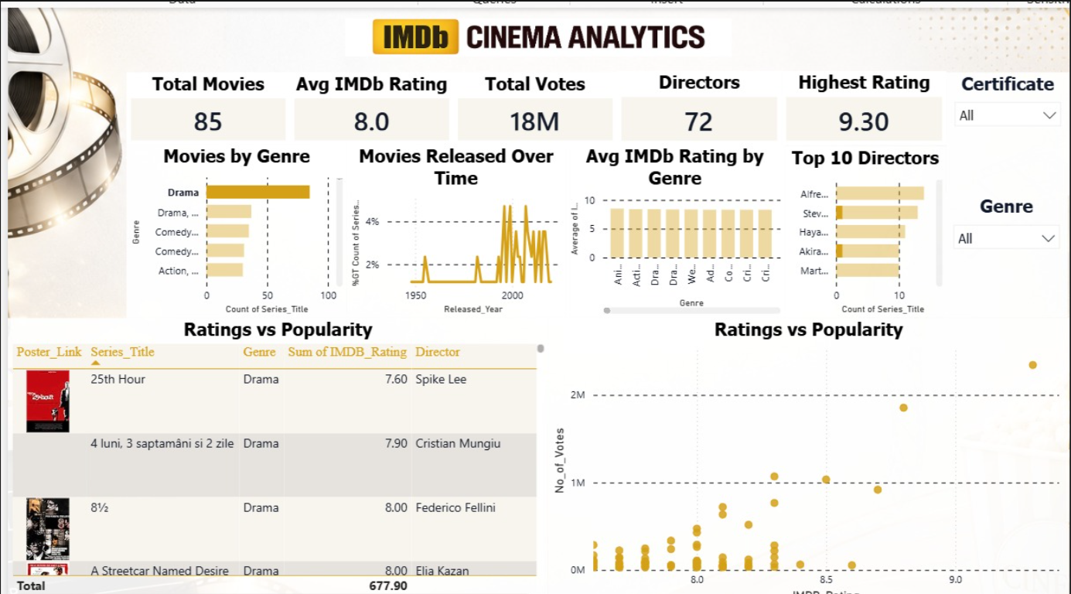

Figure 1: Dashboard

- Importing required libraries and loading the dataset

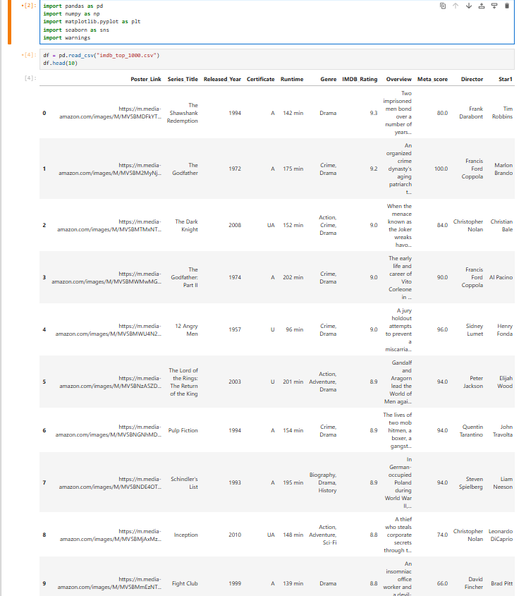

Figure 2: Dataset Overview

- Initial Data Exploration

- Viewing dataset
- Understanding structure
- Checking missing values

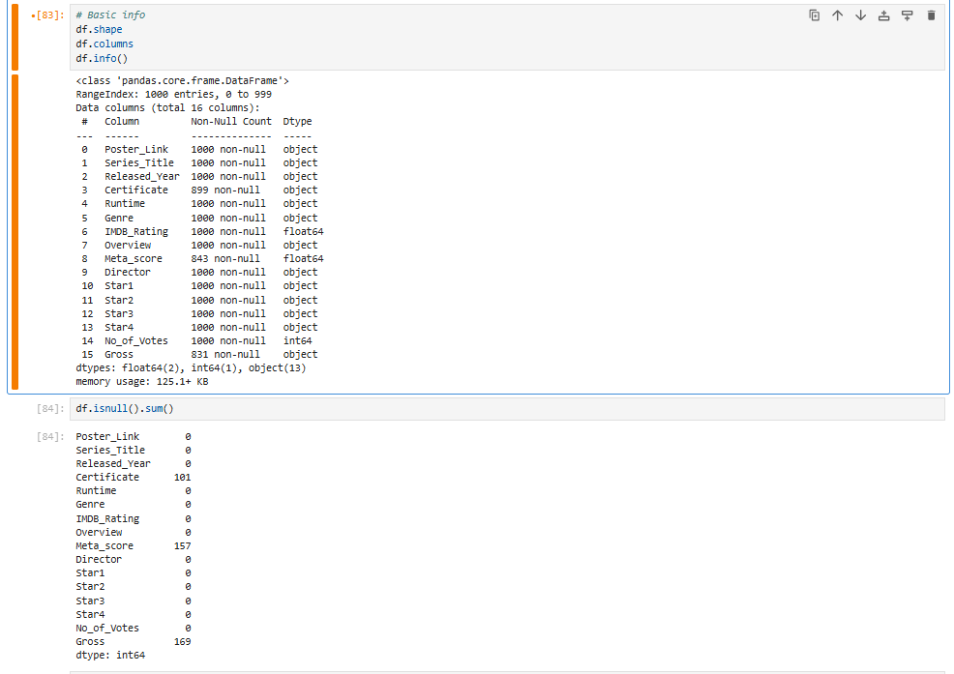

Figure 3: Data Exploration

- Data Preprocessing

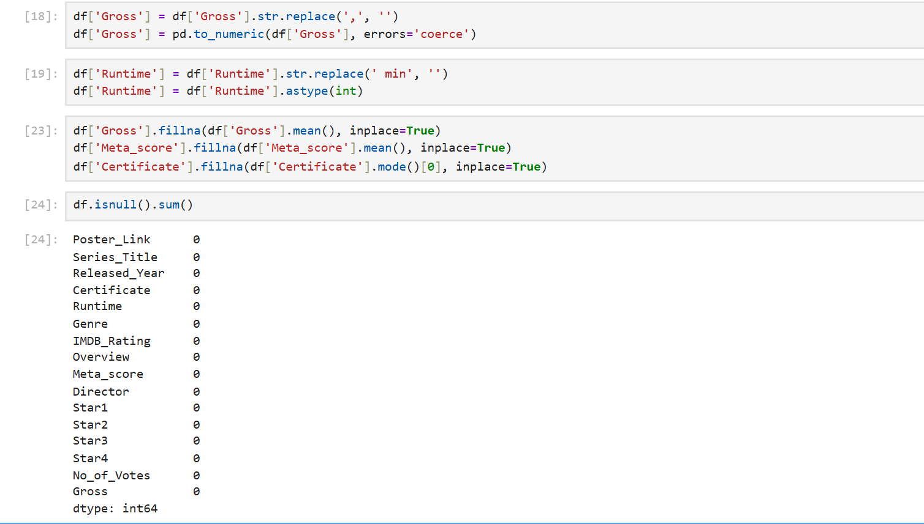

Figure 4: Data Preprocessing

- Top Rated Movies Analysis

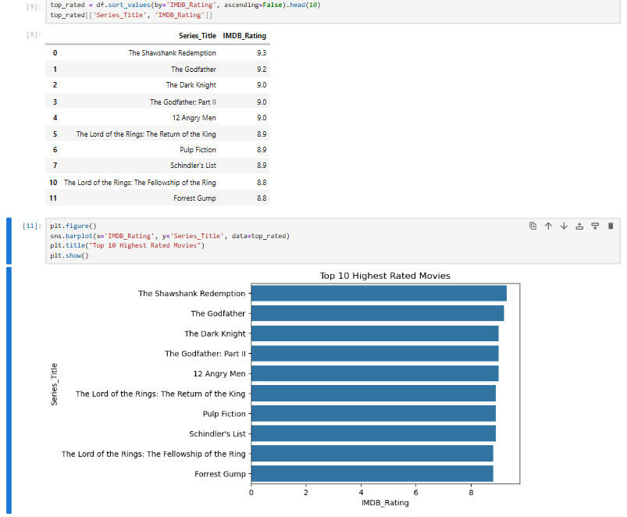

Figure 5: Top Rated Movies

- Top Actors Analysis

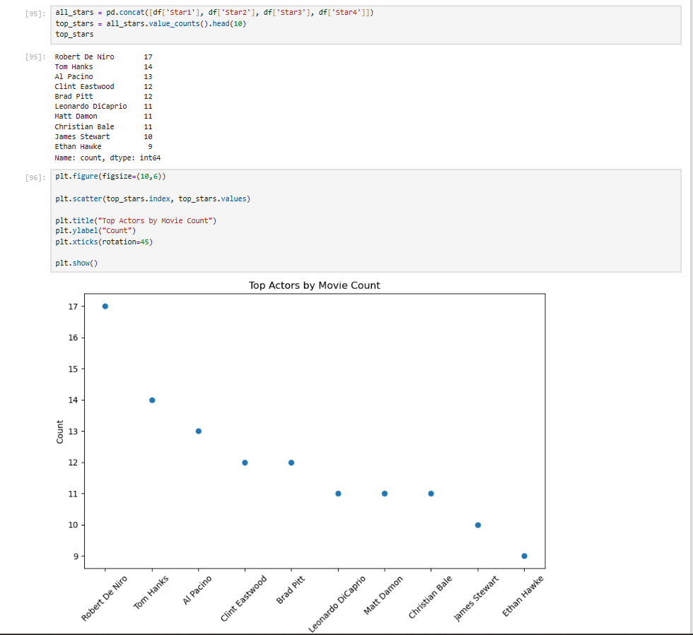

Figure 6: Top Actors

- Most Popular Movies Analysis (Based on Votes)

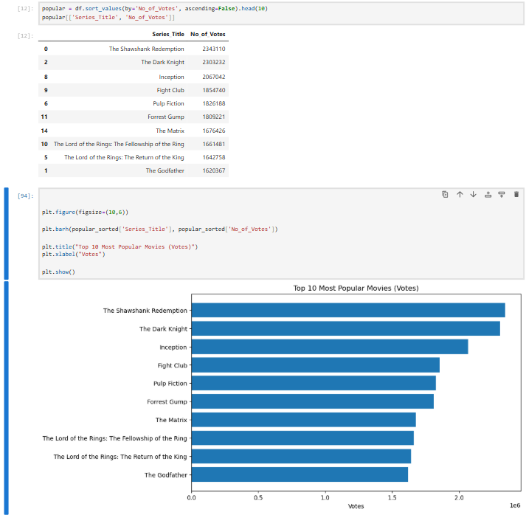

Figure 7: Most Popular Movies

- Longest Movies Analysis

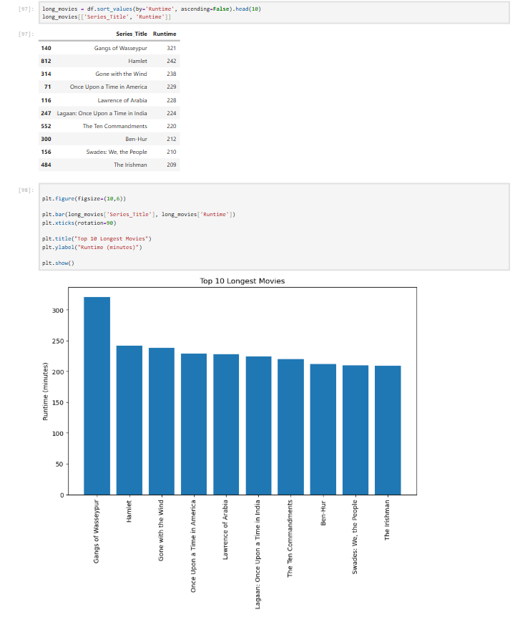

Figure 8: Longest Movies

- Highest Grossing Movies Analysis

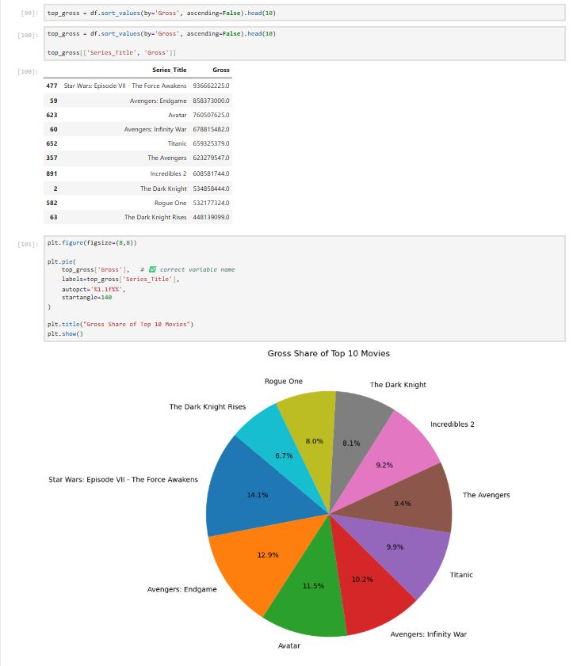

Figure 9: Highest Grossing Movies

- Genre Distribution Analysis

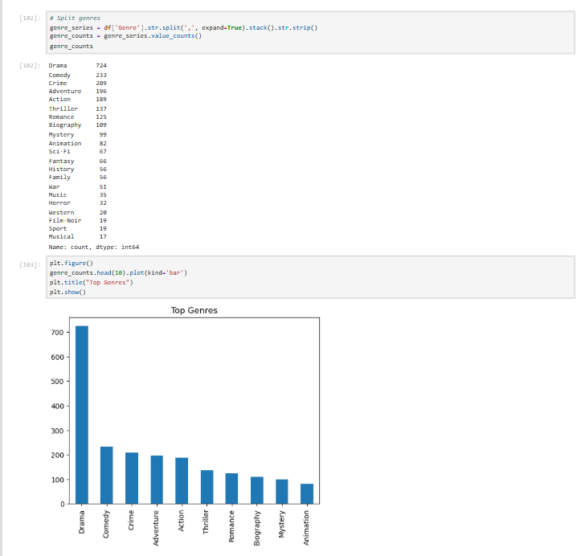

Figure 10: Genre Distribution

- Genre-wise Rating Analysis

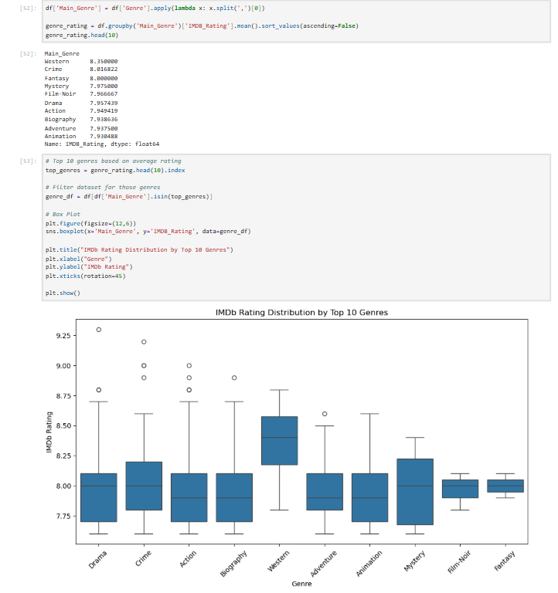

Figure 11: Genre-Wise Rating

- Movie Release Year Trend Analysis

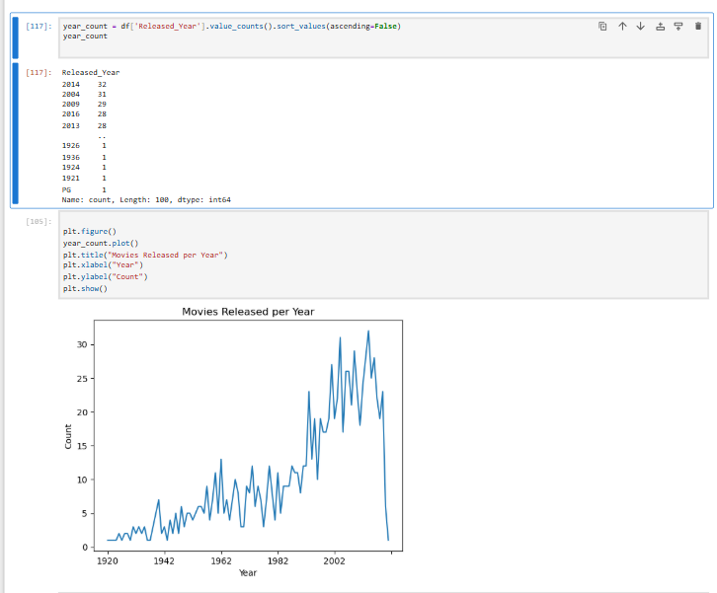

Figure 12: Movie Release Year

- Certificate-wise Analysis

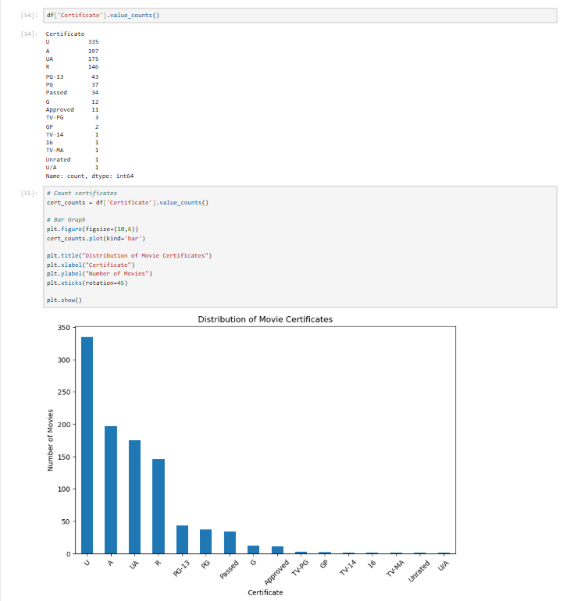

Figure 13: Certificate-Wise Analysis

- Director Analysis

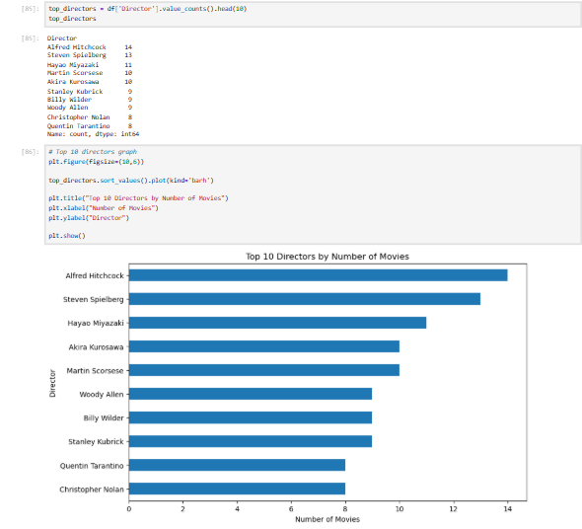

Figure 13: Director Analysis

- Correlation Analysis

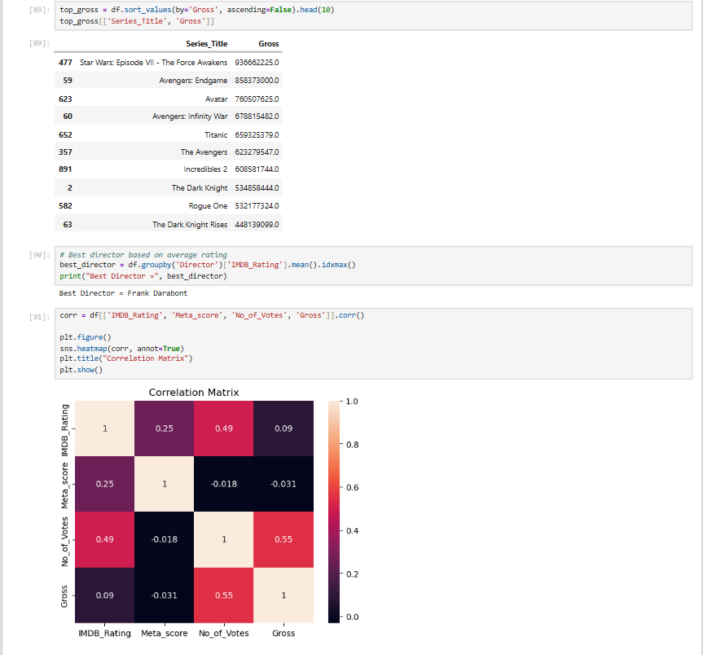

Figure 15: Correlation Analysis

5.6 REPORT ON THE ANALYSIS

- Looking at movie ratings, The Shawshank Redemption emerged as the highest-rated movie with a rating of 9.3, followed by The Godfather (9.2) and The Dark Knight (9.0).
This indicates that these films have achieved exceptional audience appreciation and critical recognition.

- In terms of popularity based on audience votes, The Shawshank Redemption received approximately 2.34 million votes, followed by The Dark Knight (2.30 million) and Inception (2.06 million).
This shows these movies have strong audience engagement and long-lasting popularity.

- Genre analysis reveals that Drama dominates the dataset with 724 movies, followed by Comedy (233) and Crime (209).
This highlights that Drama is the most common and influential genre among top-rated movies.

- However, based on average ratings, Western ranks highest with an average rating of 8.35, followed by Crime and Fantasy.
This indicates that although Western films are fewer in number, they maintain high quality.

- Actor-level analysis shows Robert De Niro appeared most frequently with 17 movies, followed by Tom Hanks (14) and Al Pacino (13).
This suggests these actors have strong representation in critically acclaimed films.

- Director analysis shows Alfred Hitchcock directed the highest number of movies (14), followed by Steven Spielberg (13) and Hayao Miyazaki (11).
This highlights the major influence of these directors in successful cinema.

- Runtime analysis reveals Gangs of Wasseypur is the longest movie in the dataset with 321 minutes, followed by Hamlet (242 minutes) and Gone with the Wind (238 minutes).
.

- Gross revenue analysis indicates Star Wars: The Force Awakens generated the highest box office revenue ($936 million), followed by Avengers: Endgame ($858 million) and Avatar ($760 million).
This shows blockbuster films dominate commercial success.

- Release year analysis reveals that 2014 recorded the highest number of top movies (32 films), followed by 2004 (31) and 2009 (29).
This indicates strong representation of successful films in recent decades.

- Certificate-wise analysis shows U certification dominates with 234 movies, followed by A (197) and UA (175).
This reflects the prevalence of broadly accessible films in the dataset.

- Popularity and revenue analysis reveals a strong relationship between Number of Votes and Gross Earnings, showing that highly popular movies often generate greater revenue.
This indicates audience engagement is a major driver of commercial success.

- Correlation analysis shows:
- Strong positive relationship between Votes and Gross
- Moderate relationship between Ratings and Votes
- Weak relationship between Meta Score and other variables
This suggests popularity influences earnings more strongly than critic scores alone.

- Overall analysis shows that movie success depends not only on ratings, but also on factors such as audience engagement, genre appeal, star cast influence, and box office performance.

- One of the most significant findings from the analysis is that higher popularity tends to lead to higher gross revenue, emphasizing the importance of audience interest in determining movie success.

5.7 FINAL INSIGHTS

- The movie dataset is heavily dominated by highly rated films, with most movies having ratings above 8.0, indicating consistently high-quality content within the IMDB Top 1000.

- The Shawshank Redemption stands out as both the highest-rated (9.3) and most popular movie (2.34 million votes), making it a benchmark of critical and audience success.

- Drama is the most dominant genre with 724 movies, showing its strong presence in cinema, while Western has the highest average rating, indicating strong quality despite lower quantity.

- Actors such as Robert De Niro, Tom Hanks, and Al Pacino, along with directors like Alfred Hitchcock and Steven Spielberg, contribute significantly to the success and quality of films in the dataset.

- Commercial success is highly concentrated among blockbuster films such as Star Wars: The Force Awakens, Avengers: Endgame, and Avatar, highlighting the major contribution of high-performing films to box office revenue.

- The analysis reveals a strong positive relationship between audience votes and gross earnings, showing that popularity plays a major role in commercial success.

- Release year analysis shows a strong presence of successful films in recent decades, especially around 2004–2014, indicating growth in high-performing modern cinema.

- Although ratings are important, the analysis suggests that audience engagement and popularity influence success more strongly than ratings alone, making votes a key performance indicator.

- Correlation analysis also shows that Meta Scores have weaker influence compared to audience-driven metrics, emphasizing that audience response often matters more than critic reviews in determining success.

- Overall, the movie industry demonstrates strong connections between ratings, popularity, revenue, genre appeal, and star influence, but audience engagement emerges as the most significant factor driving success.

- Improving understanding of these patterns can help support better decision-making in areas such as movie production, marketing strategies, and audience targeting.

- In conclusion, the analysis shows that movie success is not determined by a single factor, but by a combination of quality, popularity, commercial performance, and audience interest, which together shape long-term cinematic success.

CHAPTER 6: FUTURE SCOPE AND CONCLUSION
Conclusion
From this analysis, it is clear that data plays an important role in understanding movie performance and success.

The IMDB dataset reveals that movie success is influenced by multiple factors including ratings, audience popularity, genres, and cast.

One important observation is that popularity measured through votes has a strong influence on gross revenue. This suggests audience engagement plays a major role in commercial success.

Drama dominates in quantity, while Western has the highest average rating, showing that quantity and quality can differ.

Actors like Robert De Niro and directors like Alfred Hitchcock have significant representation in successful films.

Another interesting insight is that recent years contributed many highly ranked movies, showing growth in quality cinema.

Overall, the analysis highlights that movie success is not determined only by ratings, but by a combination of popularity, revenue performance, genre appeal, and audience engagement.

Future Scope
- Apply Machine Learning models to predict movie success
- Build interactive dashboards using Microsoft Power BI or Tableau
- Perform sentiment analysis on movie reviews
- Build recommendation systems using movie features
- Use real-time streaming and audience data for advanced analysis

7. BIBLIOGRAPHY

- Pandas Documentation – https://docs.python.org/3/
- NumPy Documentation – https://numpy.org/doc/
- Matplotlib Documentation –https://matplotlib.org/stable/contents.html
- Seaborn Documentation –https://seaborn.pydata.org/
- IMDB Dataset - https://www.kaggle.com/datasets/harshitshankhdhar/imdb-dataset-of-top-1000-movies-and-tv-shows

CONCLUSION

This project has been an incredibly enriching journey that significantly strengthened my practical understanding of data analysis and its real-world applications. Through hands-on work with the IMDB Top 1000 Movies dataset, I developed a clearer perspective on how data can be used to analyze movie performance, understand audience behavior, and evaluate factors influencing success.
Working with a structured movie dataset allowed me to sharpen my skills in data cleaning, preprocessing, exploratory data analysis, and visualization. I gained practical experience in transforming raw data into meaningful insights by analyzing trends across ratings, genres, actors, directors, popularity, and box office earnings. This process enhanced my ability to handle real-world data challenges and extract valuable insights from complex datasets.
Beyond technical skills, this project improved my analytical thinking and problem-solving abilities. I learned how to interpret patterns in data, identify key factors affecting movie success, and connect insights to real-world industry scenarios. For instance, understanding the relationship between audience votes and gross earnings, along with identifying genre and release year trends, helped me appreciate how data can reveal meaningful patterns and support informed decisions.
Additionally, the project strengthened my ability to communicate findings effectively. By presenting insights through clear visualizations and structured reporting, I developed the skill of explaining complex data in a simple and understandable manner, making it accessible even to non-technical audiences.
Overall, this project has reinforced my interest in the field of data science and analytics. The practical exposure and experience gained have equipped me with confidence and foundational skills required to grow further and contribute effectively in a data-driven environment.

REMARKS

This is to certify that Mr. Shivakanth V has successfully completed the project titled “IMDB Top 1000 Movies Analysis using Python” as part of his academic work. During the course of this project, he worked sincerely and contributed meaningfully to all phases of data collection, preprocessing, analysis, visualization, and insight generation.
He displayed excellent enthusiasm and a strong willingness to learn and apply data analytics concepts in a practical environment. He approached the project with dedication and professionalism, and demonstrated the ability to understand analytical concepts and implement them effectively using Python tools.
Throughout the project, he showed good analytical thinking, problem-solving ability, and technical competence in handling real-world data. His work on identifying patterns related to movie ratings, popularity, genres, actors, directors, and revenue reflects a strong understanding of data analysis techniques.
He completed the project successfully and presented the findings in a clear and structured manner. His performance during this project reflects both technical capability and a positive learning attitude.
We believe he possesses the skills and potential to excel in his future academic and professional journey, and we wish him continued success in all his future endeavors.
AYSHATH LUBNA
Internship Program Head



